**End of Line (EOL) Test for Glove Procedure**

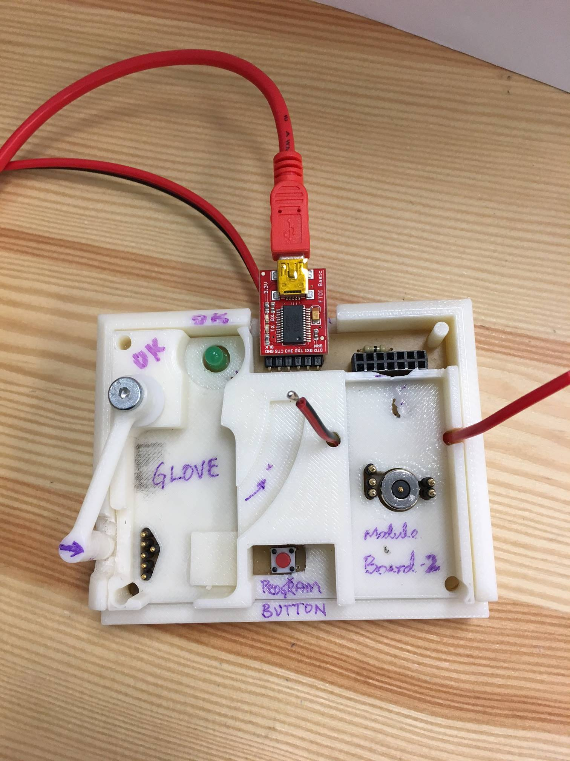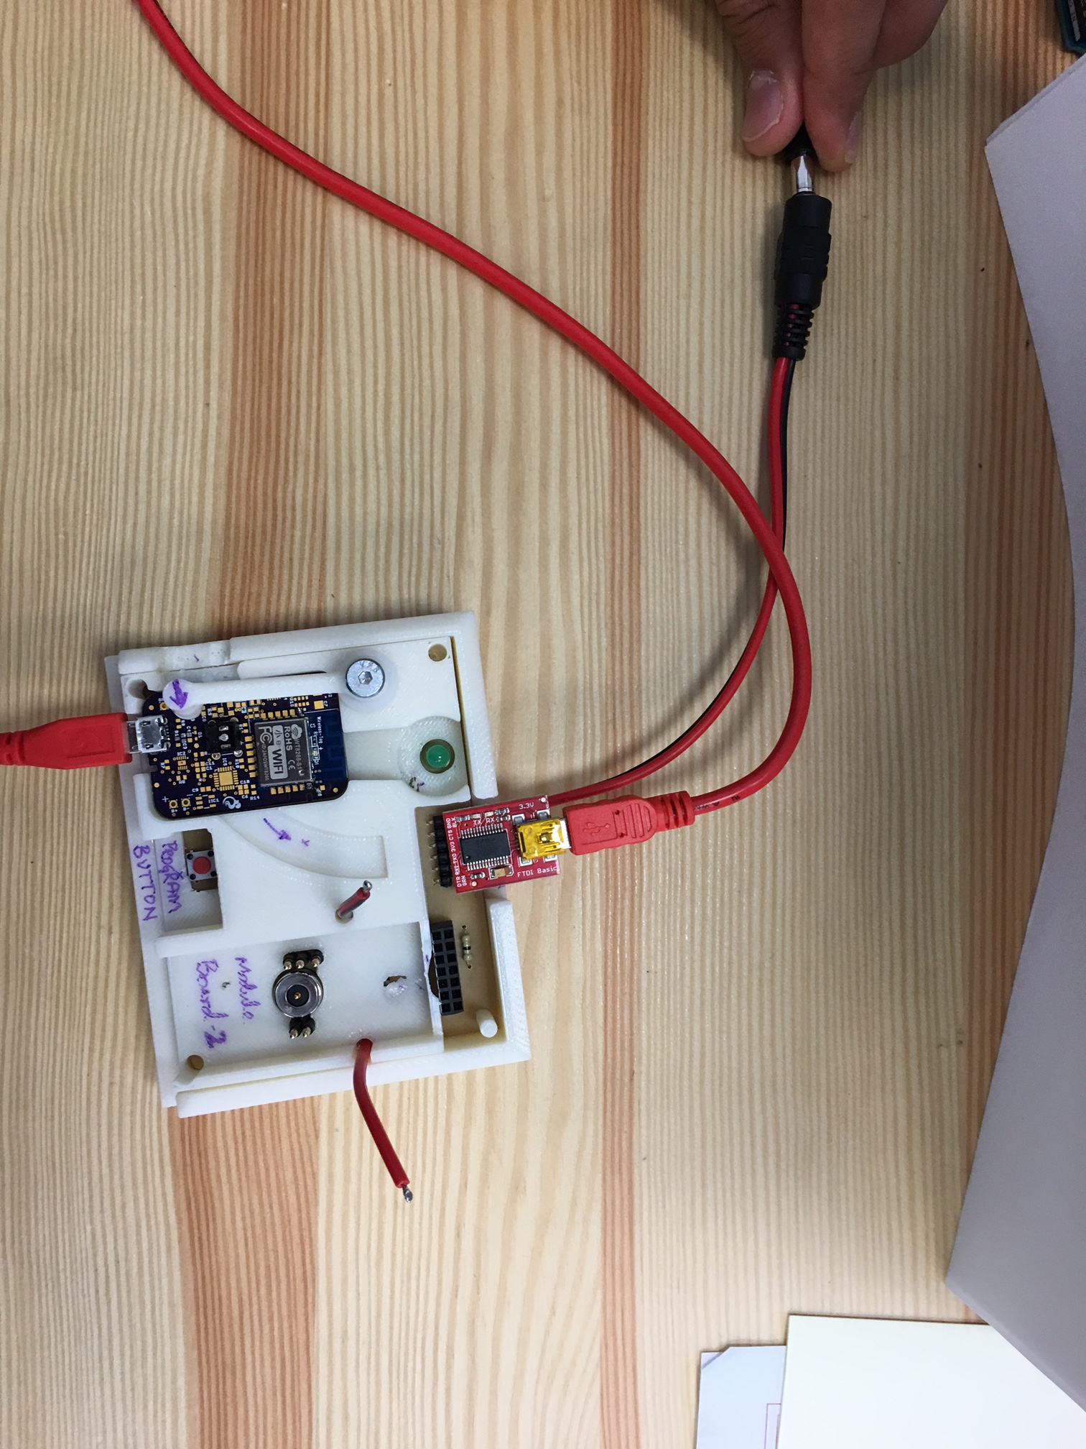

**Setup of Programmer (DO ONLY ONCE):**

1

**3. Double CLICK DeviceMgr.bat**

**1. Unzip 2.OPEN**



**4. DOUBLE CLICK RunThis.bat**

**5. ENTER ONLY  
 NUMBER**

**6. Press Enter**

**SUCCESS**

**Programmer Ready**

**Insert 9V DC**

**Insert USB Cable**

1. **Insert USB Cable into Computer**
2. **Insert USB-B Type into FTDI**
3. **Insert 9V DC Adapter**

**Setup of Installer (Do ONLY ONCE):** 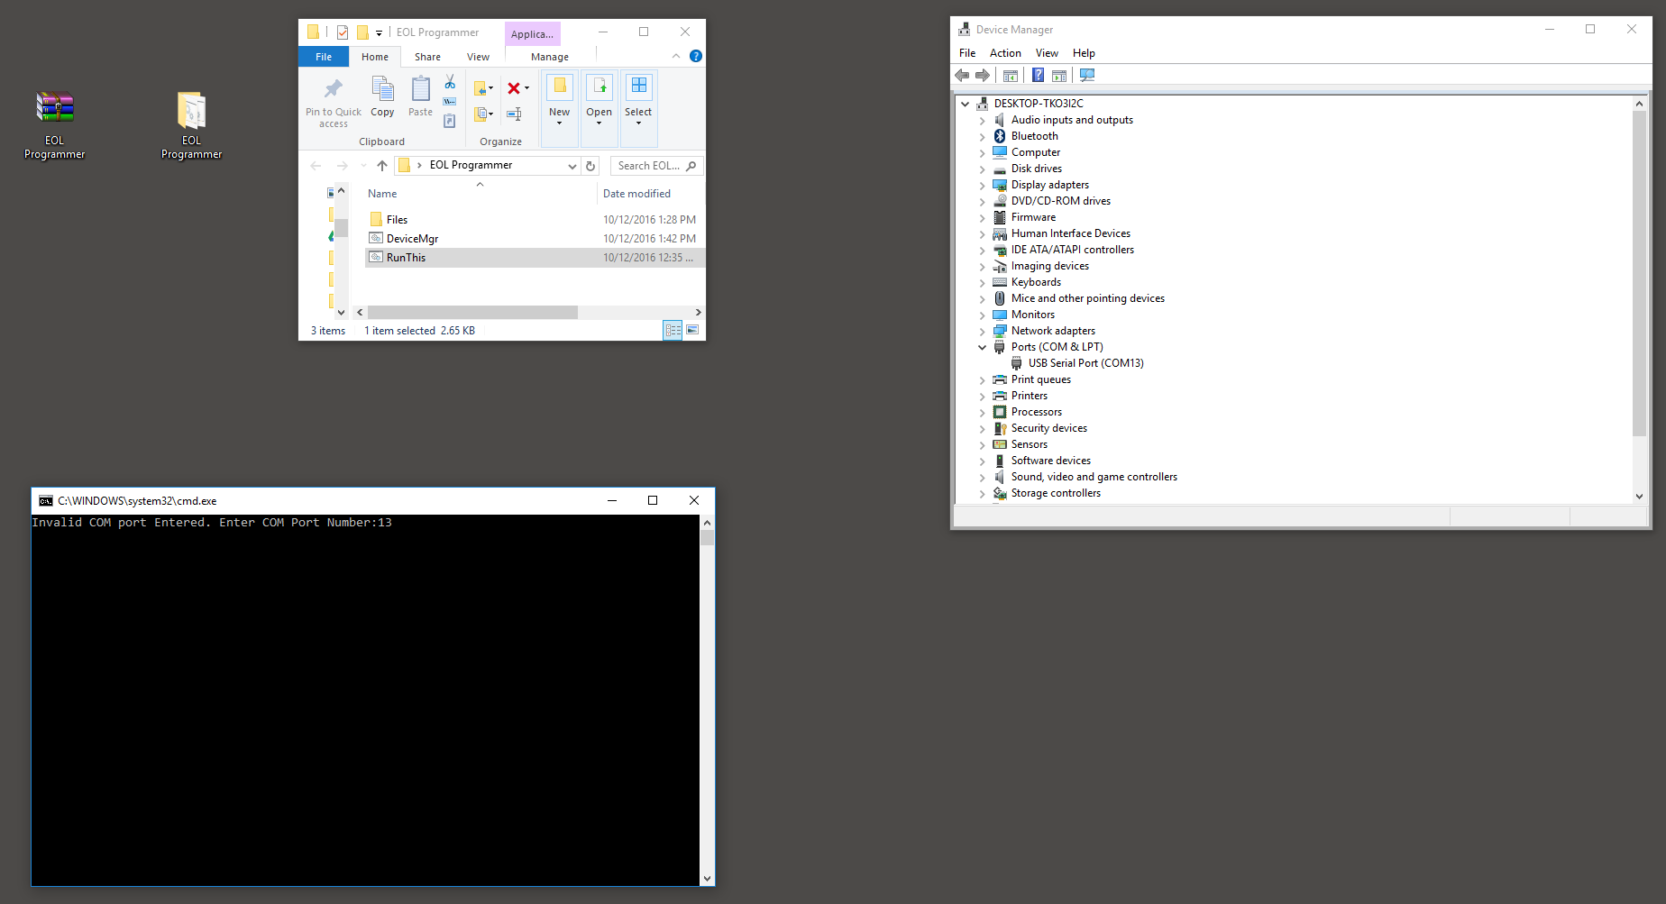

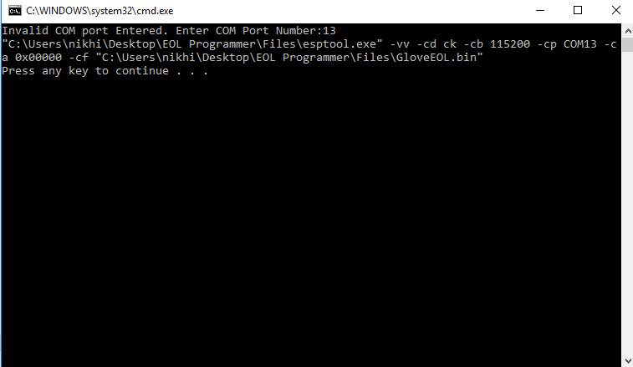

**DO NOT CLOSE THIS WINDOW**



**Setup of Installer (Once More):**

1. **Unzip and Extract the compressed folder for the Glove:**
2. **Open the Folder**
3. **Double-Click the DeviceMgr.bat and find the Ports (COM & LPT)**
4. **Double-Click RunThis.bat**
5. **Enter Number from Step 3.**
6. **Press Enter.**

**PROGRAMMING STEPS:**

Step # 1: Insert USB into Glove PCB

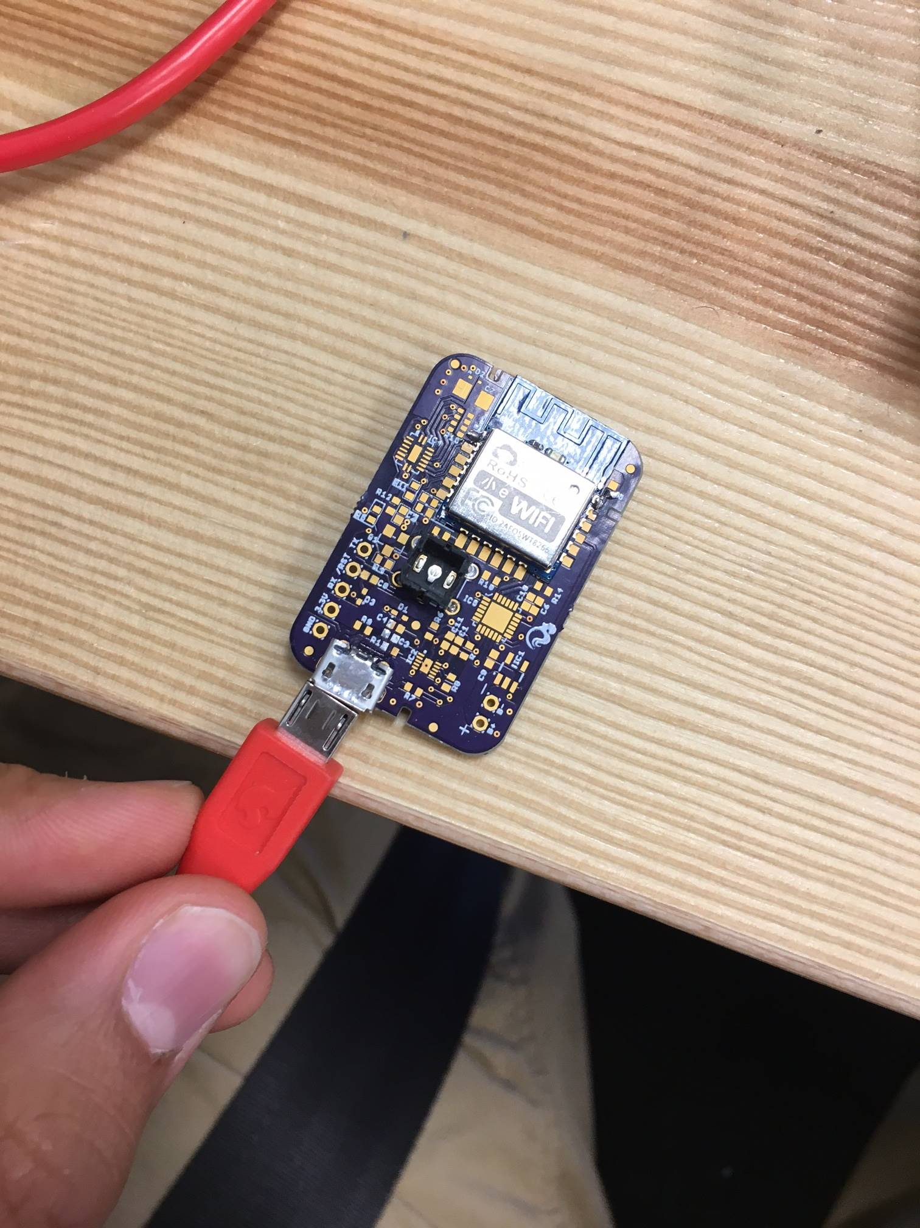

Step #2: Insert Glove PCB Into Programmer & Lock Programmer Till Green Line

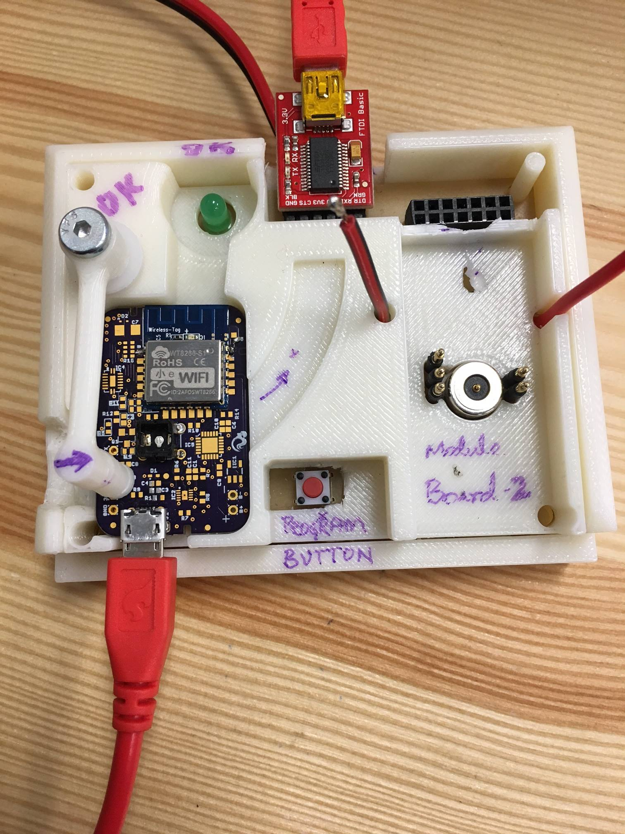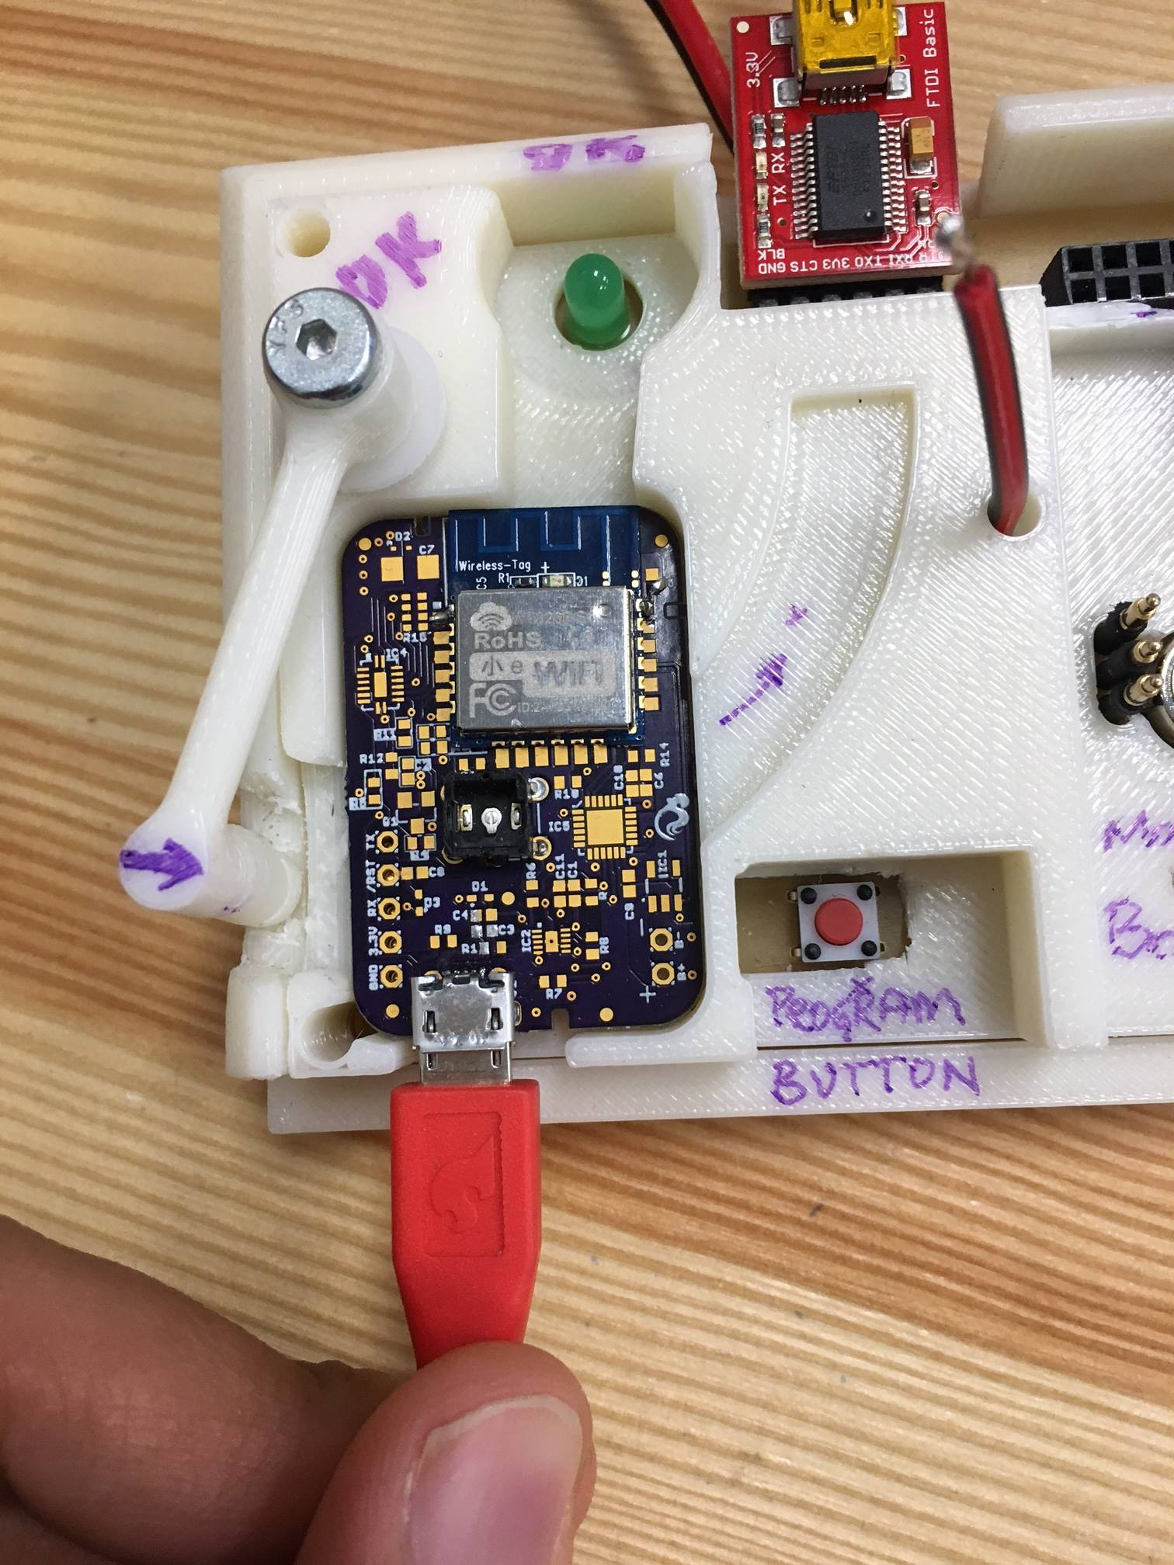

Step 3: Push Button On Programmer for **5**sec => Download Begins

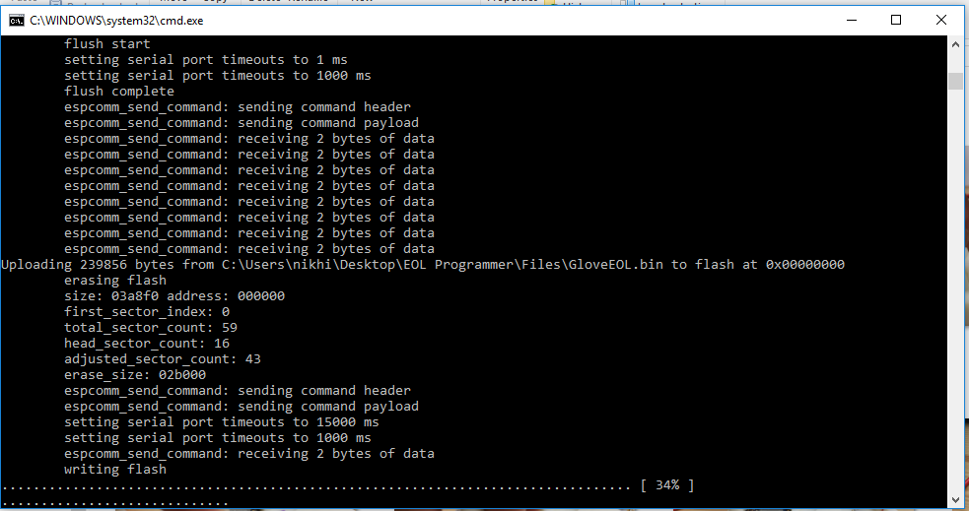

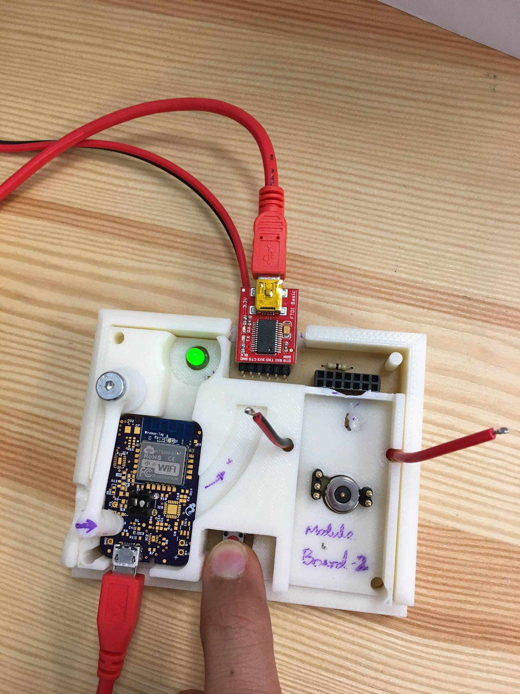

**Light Blink during Download**

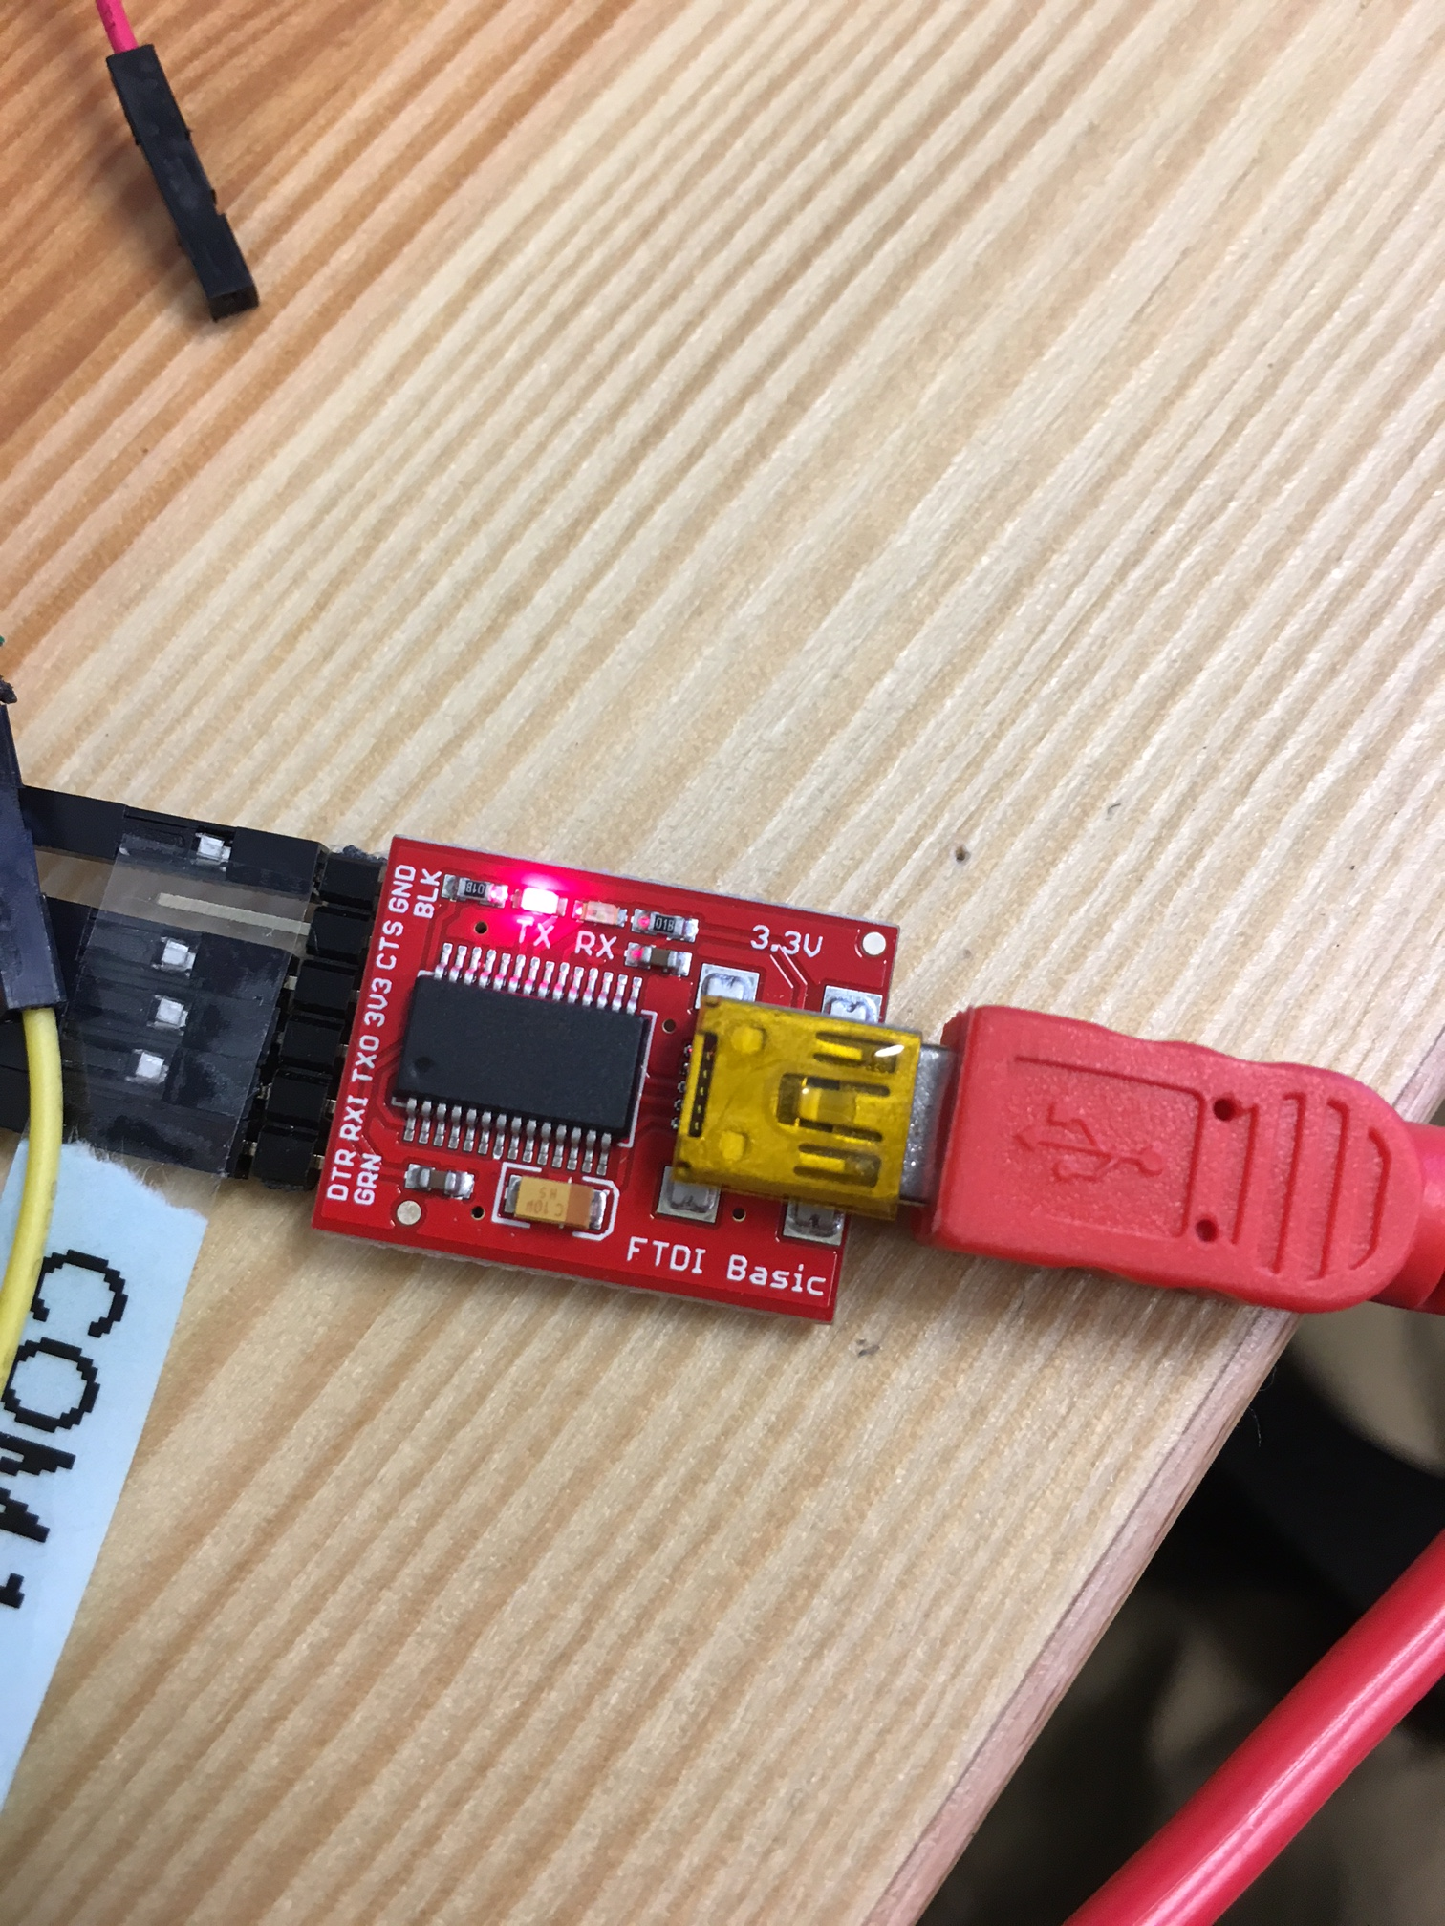

Download Begins. Status shown on Screen

Press Button for **5** sec

Step 4: After Download, Red button on Glove PCB will begin blinking. Press it.

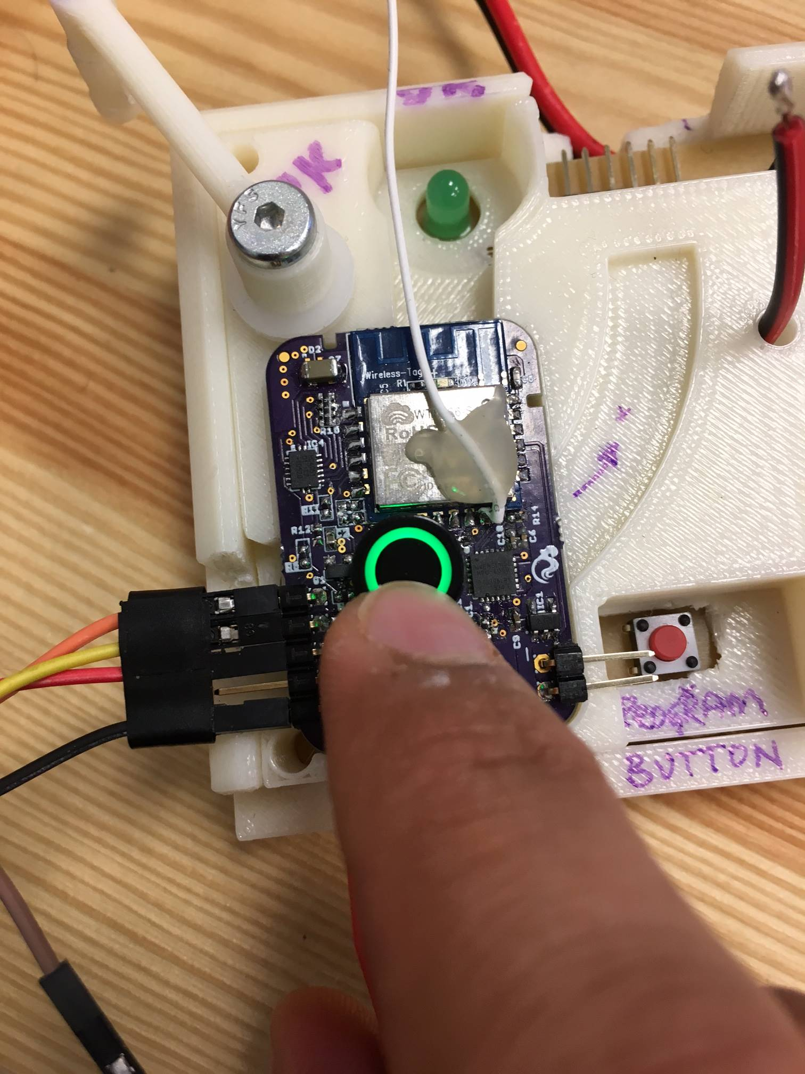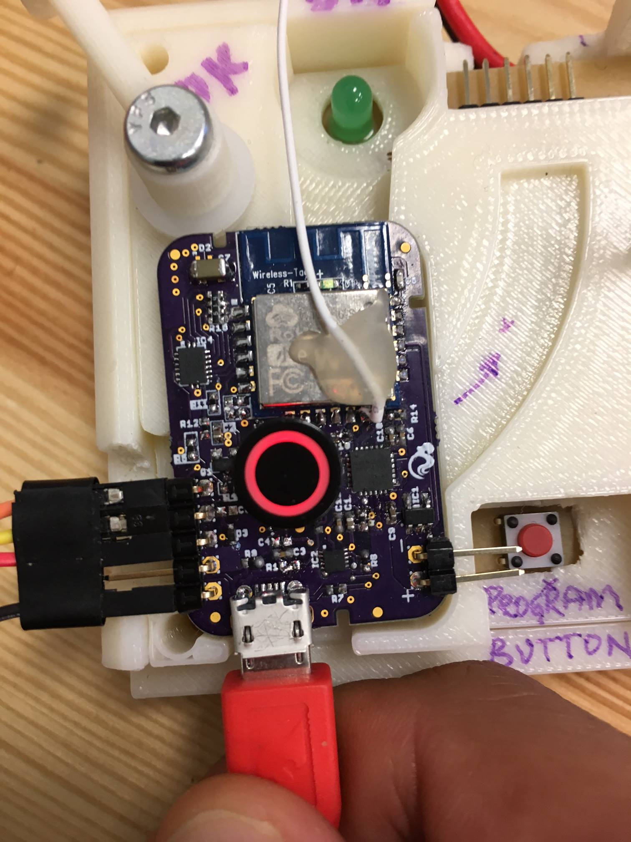

**Press Red Light**

**Debug Info:**

**Red Light Blinks**

**Press Red Light**

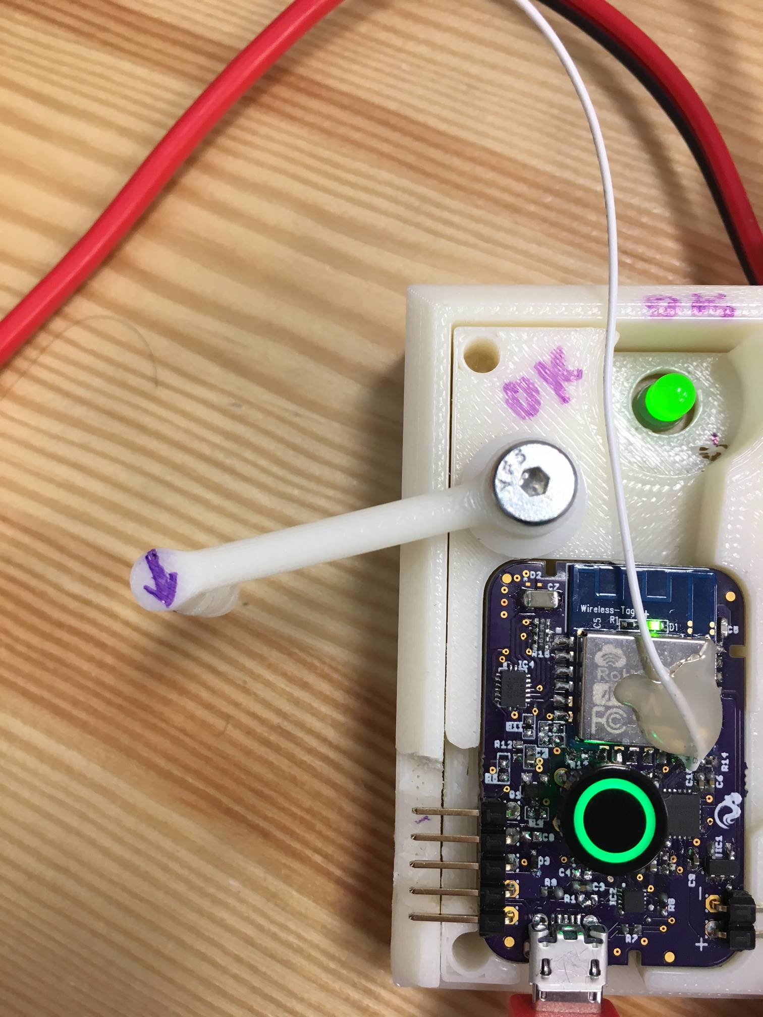

IF BOTH LIGHTS TURN GREEN=> **SUCCESS**

Repeat Steps 1 to 4

For any other questions call **+1-765-476-3370** or email **nikhil@zeroui.com**